Mega_Multi-Site Enterprise Network Infrastructure (Cisco)

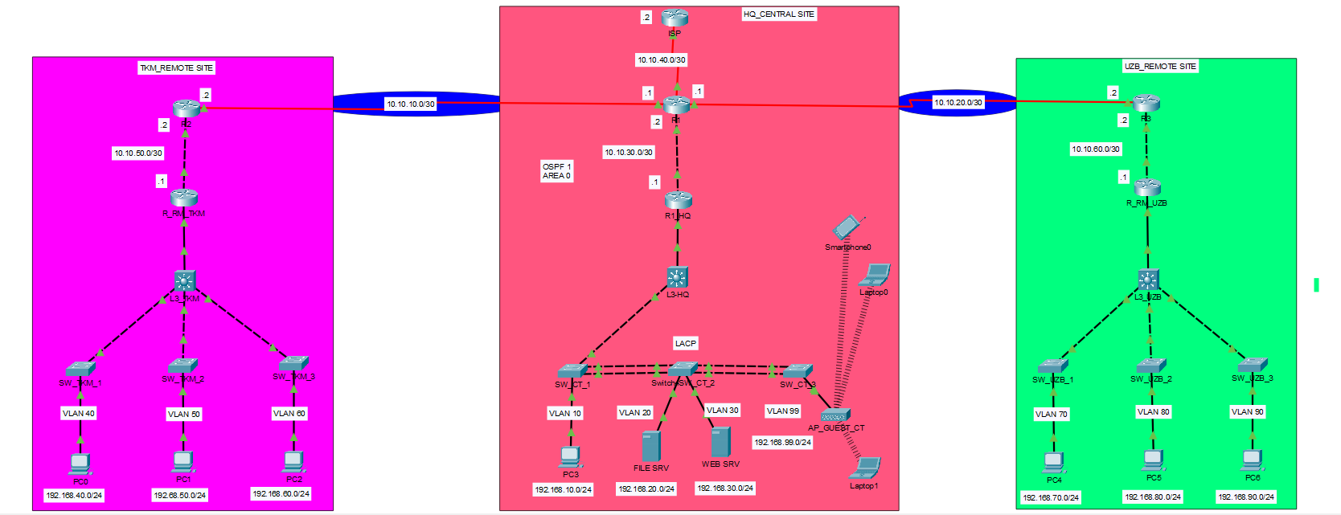
1. Project Overview
This project demonstrates the design and implementation of a multi-site enterprise network using Cisco networking technologies and Cisco Packet Tracer.
The network consists of a Headquarters (HQ) and two remote offices, Turkmenistan (TKM) and Uzbekistan (UZB), interconnected through a Wide Area Network (WAN).
The infrastructure is designed to demonstrate enterprise routing and switching, network segmentation, inter-VLAN communication, network services, wireless connectivity, and security controls.
Project Objectives
- Design a scalable enterprise LAN and WAN infrastructure.
- Establish connectivity between headquarters and remote offices.
- Implement VLAN segmentation and inter-VLAN routing.
- Configure OSPF dynamic routing across all three sites.
- Implement EtherChannel using LACP for link aggregation.
- Configure network services and centralized server connectivity.
- Provide wireless connectivity through a dedicated guest VLAN.
- Implement extended Access Control Lists (ACLs) to isolate guest Wi-Fi users from internal corporate networks.
- Verify connectivity and troubleshoot network configurations using Cisco IOS commands.

2. Network Topology
The network consists of three interconnected locations:
Headquarters (HQ)
- Central WAN router and internal routing infrastructure
- Layer 3 switch and access switches
- Corporate VLANs 10, 20, and 30
- Guest Wi-Fi VLAN 99
- File server and web server
- EtherChannel connections using LACP
- Connection to an ISP router
Remote Site 1 — Turkmenistan (TKM)
- WAN router and internal router
- Layer 3 switch and three access switches
- VLANs 40, 50, and 60
- Workstations distributed across separate VLANs
Remote Site 2 — Uzbekistan (UZB)
- WAN router and internal router
- Layer 3 switch and three access switches
- VLANs 70, 80, and 90
- Workstations distributed across separate VLANs

3. IP Addressing and VLAN Design
Site | VLAN | Network | Purpose
HQ | 10 | 192.168.10.0/24 | Corporate workstations
HQ | 20 | 192.168.20.0/24 | File server
HQ | 30 | 192.168.30.0/24 | Web server
HQ | 99 | 192.168.99.0/24 | Guest wireless network
TKM | 40 | 192.168.40.0/24 | Workstations
TKM | 50 | 192.168.50.0/24 | Workstations
TKM | 60 | 192.168.60.0/24 | Workstations
UZB | 70 | 192.168.70.0/24 | Workstations
UZB | 80 | 192.168.80.0/24 | Workstations
UZB | 90 | 192.168.90.0/24 | Workstations

WAN Addressing
WAN Connection | Network
HQ ↔ TKM | 10.10.10.0/30
HQ ↔ UZB | 10.10.20.0/30
HQ WAN Router ↔ R1_HQ | 10.10.30.0/30
HQ ↔ ISP | 10.10.40.0/30
TKM WAN Router ↔ Internal Router | 10.10.50.0/30
UZB WAN Router ↔ Internal Router | 10.10.60.0/30

4. Dynamic Routing — OSPF
Open Shortest Path First (OSPF) is used as the dynamic routing protocol for communication between headquarters and the remote offices.
Routing design:
- OSPF Process ID: 1
- OSPF Area: 0 (Backbone)
- Dynamic exchange of routing information between sites
- Routing connectivity between geographically separated VLAN networks
OSPF Configuration
router ospf 1
network 10.10.30.0 0.0.0.3 area 0
network 192.168.10.0 0.0.0.255 area 0
network 192.168.20.0 0.0.0.255 area 0
network 192.168.30.0 0.0.0.255 area 0
network 192.168.99.0 0.0.0.255 area 0
The configuration is illustrative; OSPF network statements are applied on the router that owns the corresponding interfaces.
Verification Commands
show ip ospf neighbor
show ip route ospf
show ip protocols
show ip ospf interface brief
5. VLAN Segmentation and Inter-VLAN Routing
VLANs are used to separate corporate workstations, servers, and guest wireless devices into distinct broadcast domains.
Inter-VLAN routing enables communication between authorized VLANs through Layer 3 gateway interfaces.

Commands for Router-on-a-Stick Configuration
interface GigabitEthernet0/0/1.10
encapsulation dot1Q 10
ip address 192.168.10.1 255.255.255.0

interface GigabitEthernet0/0/1.20
encapsulation dot1Q 20
ip address 192.168.20.1 255.255.255.0

interface GigabitEthernet0/0/1.30
encapsulation dot1Q 30
ip address 192.168.30.1 255.255.255.0

interface GigabitEthernet0/0/1.99
encapsulation dot1Q 99
ip address 192.168.99.1 255.255.255.0
Interface names and gateway addresses must match the actual router configuration.
6. EtherChannel — LACP
Link Aggregation Control Protocol (LACP) is used at headquarters to combine multiple physical Ethernet links into logical EtherChannel connections.
Benefits:
- Increased aggregate bandwidth
- Link redundancy
- Improved availability
- Simplified logical link management

LACP Configuration
interface range FastEthernet0/1 - 2
switchport mode trunk
channel-group 1 mode active
no shutdown

interface Port-channel1
switchport mode trunk
The corresponding switch must have a compatible EtherChannel configuration.
Verification
show etherchannel summary
show lacp neighbor
show interfaces trunk
7. Guest Wi-Fi Network Security — Extended ACL
A dedicated wireless network is designed for guest users at headquarters.
Guest network:
- VLAN: 99
- Network: 192.168.99.0/24
- Wireless access point: AP_GUEST_CT
The security objective is to allow guest users to access permitted external networks while preventing access to internal corporate VLANs, servers, and router infrastructure.
Extended ACL Configuration
ip access-list extended GUEST_WIFI_ACL
deny ip 192.168.99.0 0.0.0.255 192.168.0.0 0.0.255.255
deny ip 192.168.99.0 0.0.0.255 10.10.0.0 0.0.255.255
permit ip 192.168.99.0 0.0.0.255 any
The ACL is intended to be applied inbound on the Layer 3 interface serving VLAN 99.
Example Application
interface GigabitEthernet0/0/1.99
ip access-group GUEST_WIFI_ACL in
If the VLAN gateway is configured on a Layer 3 switch instead, the ACL should be applied to the corresponding VLAN 99 SVI.
Expected Security Behavior
Traffic | Expected Result
Guest Wi-Fi → HQ corporate VLANs | Denied
Guest Wi-Fi → HQ file server | Denied
Guest Wi-Fi → HQ web server | Denied
Guest Wi-Fi → TKM internal networks | Denied
Guest Wi-Fi → UZB internal networks | Denied
Guest Wi-Fi → Internal router transit IPs | Denied
Guest Wi-Fi → Permitted external destinations | Allowed by ACL
Internet connectivity additionally depends on appropriate routing and NAT configuration.
8. Network Services and Servers
The HQ network includes dedicated servers:
File Server — VLAN 20
- Network: 192.168.20.0/24
- Provides a dedicated segment for enterprise file services.
Web Server — VLAN 30
- Network: 192.168.30.0/24
- Provides a dedicated segment for web services.
Separating servers into different VLANs supports network organization and enables more granular security policies.
9. Network Verification and Troubleshooting
Cisco IOS commands are used to verify routing, switching, and security configurations.
Routing
show ip route
show ip ospf neighbor
show ip route ospf
ping
traceroute
VLANs and Switching
show vlan brief
show interfaces trunk
show interfaces switchport
EtherChannel
show etherchannel summary
show lacp neighbor
Security
show access-lists
show ip interface
show running-config
Connectivity Testing
Testing should include:
- Communication between authorized VLANs.
- Connectivity between HQ and remote offices.
- Access to internal servers from authorized workstations.
- Guest Wi-Fi isolation from corporate VLANs and router interfaces.
- Verification of OSPF neighbor relationships and learned routes.
- Verification of EtherChannel operational status.

10. Technologies and Tools
- Cisco Packet Tracer
- Cisco IOS CLI
- IPv4 Addressing and Subnetting
- VLANs and IEEE 802.1Q Trunking
- Inter-VLAN Routing
- OSPFv2
- EtherChannel and LACP
- Extended Access Control Lists (ACLs)
- Wireless LAN Networking
- Enterprise LAN/WAN Design
- Network Troubleshooting
11. Project Conclusion
This project provides a practical demonstration of enterprise network infrastructure design across multiple locations.
It integrates routing, switching, VLAN segmentation, WAN connectivity, server networks, wireless access, and network security into a unified Cisco networking environment.
The project supports the development of hands-on skills in network engineering, network administration, and cybersecurity.

Author: Atajan Rozymuradov
Focus Areas: Cisco Networking | Network Security | Enterprise Infrastructure | Cybersecurity

